**FREQUENT PATTERN MINING USING ASSOCIATION RULE**

**THROUGH**

**WEKA AND R TOOLS**

**DESCRIPTION :**

Consider a dataset of 2015.csv file of which it contains the attributes are Reference Number, Grid ref: Easting, Grid Ref: Northing, Number of vehicles, Accident date, Time(24 hr), 1st Road class, Road Surface, Lighting conditions, Weather conditions, casuality class, Sex of casuality, Age of casuality, Type of casuality for the performance of the dataset by applying the Apriori algorithm in weka and as well using R- tool.

* **USING WEKA TOOL :**

**STEPS INVOLVED :**

* Choose a set of attributes for clustering and for giving a motivation.
* Choose the dataset and import the dataset into Weka tool.
* Discretize the attributes from numeric to nominal to perform the algorithm.
* Cluster the dataset and choose simple Apriori algorithm.
* Set the Upper bound min_sup and lower bound min_sup values.

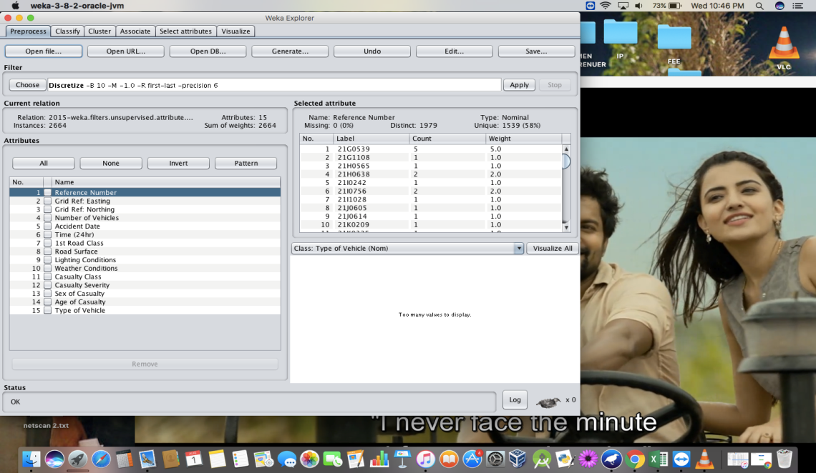

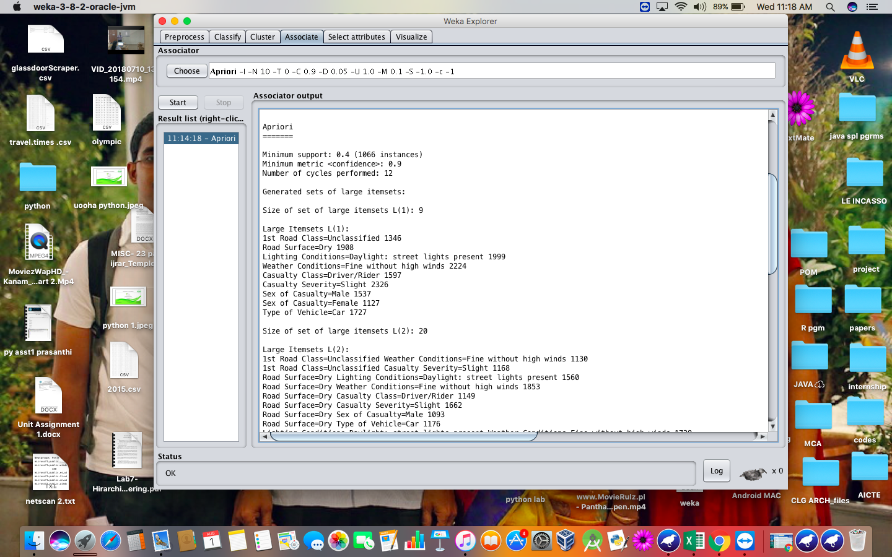

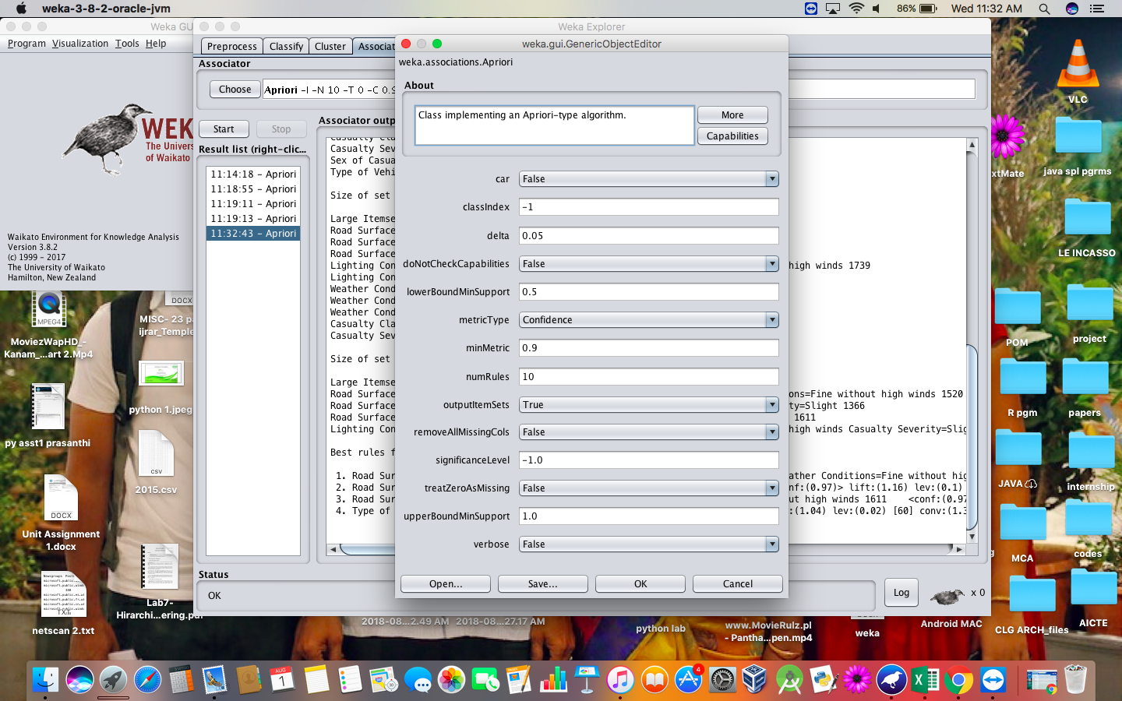

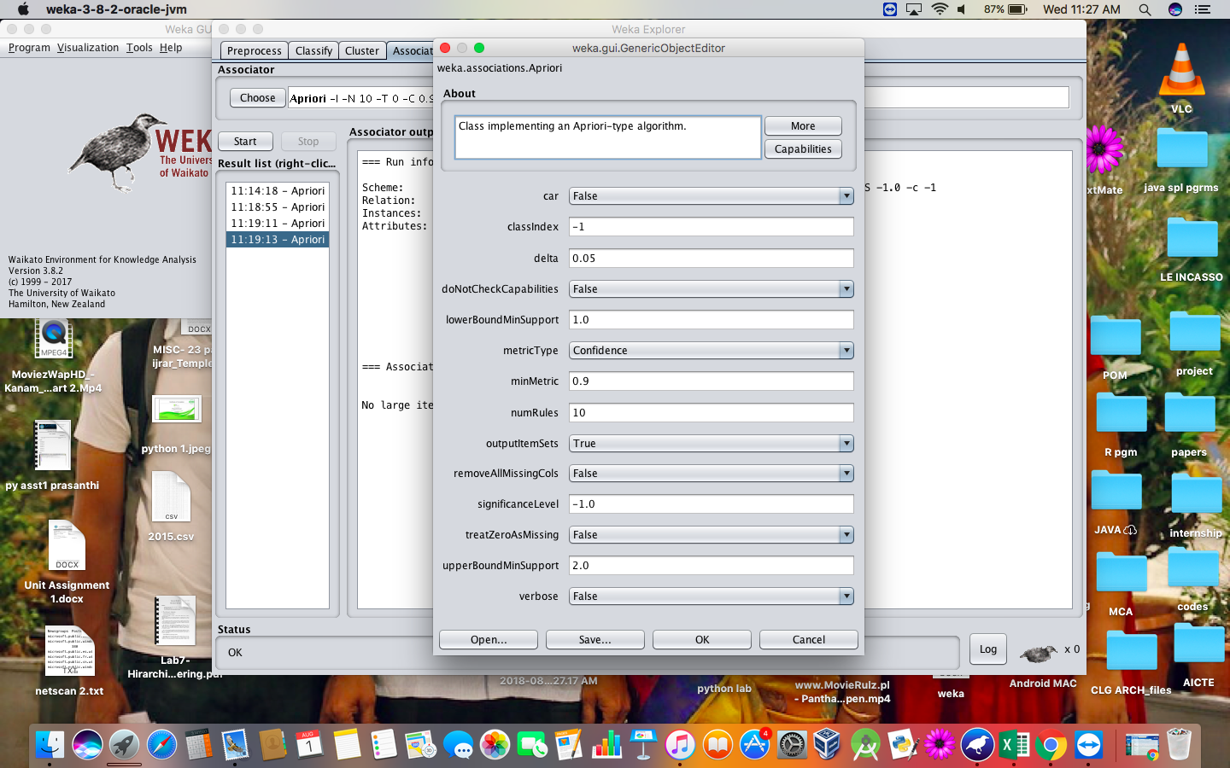

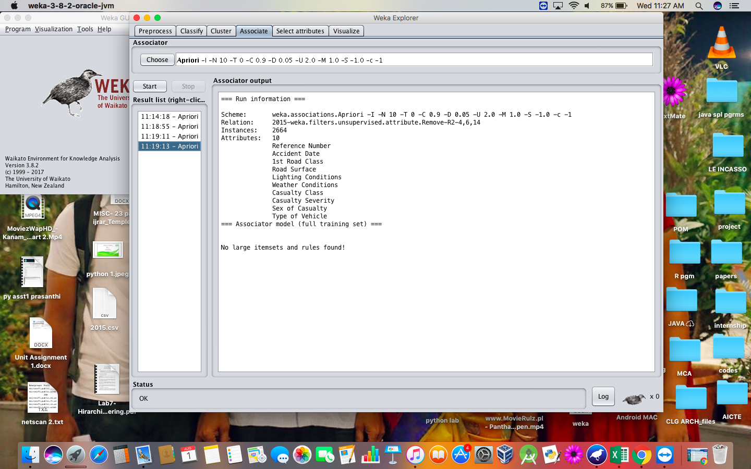

**RESULT :**

Thus, the Apriori algorithm analyzing using both the weka tool and R- tool has been successfully completed. In case of weka tool, the change in upper bound and lower bound values lead to the increase and decrease of number of itemsets and rules . In case of R-tool, there is an increase in absolute minimum support count value.